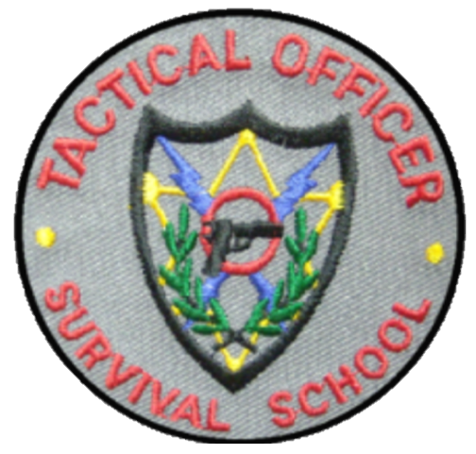
Tactical Officer Survival School

PRESENTS

COMBAT HANDGUN INSTRUCTOR CLASS

HOSTED BY
MLEOTA April 10-12, 2023

Student registration form

Name ___________________________________ Rank _______________________

Agency ________________________________Email__________________________________

Address ______________________________________________________________________

Telephone # _______________________________ fax # __________________________

Tuition- $450/per officer Check or PO enclosed ______________________

Make Checks or PO to: TACTICAL OFFICER SURVIVAL SCHOOL
PO BOX 391
SOUTHAVEN, MISSISSIPPI 38671
Attention: Tom Long 901-351-6254

Please email registration form to: tomlongtoss@yahoo.com
Registration form must be received before you can attend. Check or Purchase Order must be received to hold your slot in the training.
Class will be held
Day 1: 0830-1630 MLEOTA Range
Day 2: 1230-2030 Pearl, MS
Day 3: 0830-1630

Needed for class:
- Handgun W/3 magazines
- Holster, Belt & Mag. Pouch
- Proper Eye Protection
- Hearing Protections
- Rain Gear
- Flashlight (besides weapons mounted light if so equipped)
- 1000 rounds of handgun ammunition

About the Class:
This class is taught by retired Police Chief Tom Long. At the time of his retirement, Tom was the longest serving Chief of Police in the state of Mississippi at 27 years. Tom’s law enforcement career spanned 38 years as he worked his way through the ranks to become Chief of Police.

Local Information :
Lee Houston
lhouston@dps.ms.gov phone: 662-457-0594

