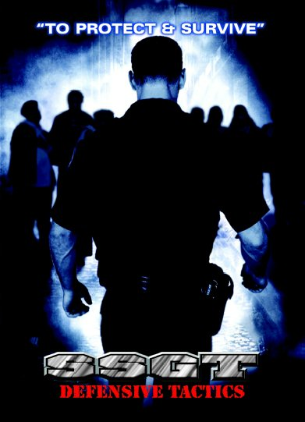
www.gossgt.com
MISSISSIPPI COURSE
VANGUARD LEVEL 1 AND 2
INSTRUCTOR COURSES
DATES
Level 1 – April 24 – 28, 2023
Level 2 – June 5 – 9, 2023
HOST
MS LAW ENFORCEMENT OFFICERS TRAINING ACADEMY
3791 Hwy 468 W.
Pearl, MS 39208

CONTACT
Tony Carleton
662-231-3201

Price
$700.00 each class
$500.00 re-certification

