
2026 Training Conference
Meet the Speakers

Leisa McElreath

Leisa Stuart McElreath joined Lafayette Oxford University (LOU) Crime Stoppers in 2009, beginning a long-standing commitment to fostering collaboration between citizens and law enforcement to prevent and solve crime. First appointed by Governor Phil Bryant to the Mississippi Crime Stoppers Advisory Council in 2016, she was later reappointed by Governor Tate Reeves. Since 2022, she has served as Chair of the Council. Leisa's academic background includes graduate studies in Social Justice and Criminology at Delta State University and a Bachelor of Science in Criminal Justice with an emphasis in Homeland Security from the University of Mississippi. Her commitment to public safety is deeply rooted in family influences, with numerous family members serving in law enforcement and criminal justice professions. She is married to Dr. David McElreath, Professor Emeritus of Criminal Justice at the University of Mississippi.

Tadd Pitts

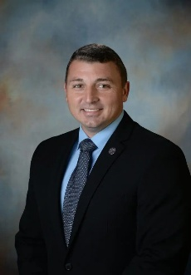
Tadd Pitts serves as Colonel for the Mississippi Highway Patrol at the Mississippi Department of Public Safety. During his tenure in law enforcement, he has worked as a deputy for the Rankin County Sheriff’s Office, served on the Governor’s policy team, and served as Executive Protection for the Mississippi Speaker of the House. Most recently, Major Pitts has served as Deputy Commissioner and Director of Governmental Affairs since 2020, where he managed MDPS legislation, handles legislative requests, and coordinates with various officials and groups to ensure effective policy measures. His role also involves analyzing proposed legislation, preparing briefing materials, and providing strategic advice to enhance the department’s legislative efforts and engagement. In addition to this, he will also oversee the Department’s outreach programs with other public entities and public information efforts. Tadd and his wife, Lindsey, live in Brandon, Mississippi and have three daughters, Madalynn, Mayley, and Mary Hayden.

Jimmy Herzog
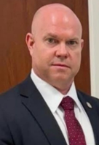
James Herzog currently serves as the Deputy Commissioner of the Mississippi Bureau of Investigation. He graduated from Mississippi College in 1992 with a Bachelor of Science in Business Administration and was a member of the 1989 NCAA National Championship football team. Prior to his law enforcement career, he served as the program director for a local non-profit agency.
Herzog began his law enforcement career in 1994 as a State Trooper. He was a member of the SWAT team, a Tact Officer and a Field Training Officer.
In 1999, Herzog joined the Mississippi Bureau of Investigation, where he conducted hundreds of homicide investigations as well as serial cases and public corruption cases. He was awarded the Lamar County Officer of the Year Award, a Life-Saving Award, Troop J Trooper of the Year Award, a Meritorious Service Award and a Distinguished Service Award. He later was assigned to the FBI Joint Terrorism Task Force on counterterrorism and national security investigations.
After a promotion to the Director of Special Operations and the Major Crime Unit in 2012, Herzog led complex investigations involving murder-for-hire, human trafficking, and other major crimes. He served as the state’s Amber Alert and Silver Alert Coordinator and developed and implemented the Endangered Missing Child Alert System for the State of Mississippi.
Herzog was appointed Deputy Director of MBI in 2017. Beginning in 2022, he served as Chief of Security for the Mississippi Department of Agriculture and Commerce where he was responsible for law-enforcement and security operations for major statewide events such as the Mississippi State Fair and the Dixie National Rodeo.
Herzog returned to MBI in February 2024 as the Director-Special Agent in Charge. He currently serves as the Sergeant-at-Arms for the National Association of State Criminal Investigative Agencies (ASCIA) and is a member of the Executive Board of the FBI Joint Terrorism Task Force.

Ned Fasullo
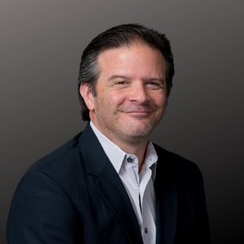
Ned’s career spans over 3 decades working with hundreds of small business and nonprofit organizations for growth consulting in sales, marketing, business development & technology to achieve success. He is a public speaker for events, media interviews, sales & marketing consulting, a published author of “The Small Book of Big Marketing” and was a Louisiana Silicon Bayou Top 100 List maker in 2012 thru 2017. Ned sits on multiple committees in the Louisiana Technical & Community College System, he’s a long-standing board member with the Louisiana Alliance for Nonprofits, and his wife Amy is a Board Member with the Capital Region Crime Stoppers in Louisiana.

Julie Levanway
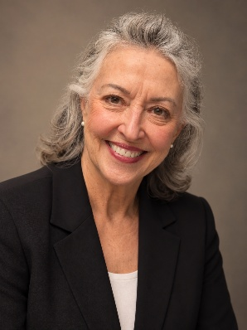
A live round. A training exercise. A mistake that never should have happened.
John Ballard Gorman was killed during a firearms training exercise when established safety protocols were not followed. Dummy weapons should have been used. Instead, a live round was discharged—by the instructor.
Less than 24 hours after receiving a well-earned promotion to director of investigations for the Mississippi Gaming Commission, 22 years in the making, John was dead.
He left behind a heartbroken family—and a seven-year-old daughter who would grow up without her father.
His sister, Julie Gorman Levaway, turned that unimaginable loss into a mission: helping ensure firearms instructors have the training, protocols, and commitment to safety necessary to prevent another tragedy like John’s.
Julie is a native Mississippian, a mother, grandmother, caterer, television chef, culinary arts teacher, and radio host. But today, her work is about something much bigger than any one career.
It’s about making sure instructors follow the protocols that can mean the difference between someone going home—and someone never coming home.

Paul Holley
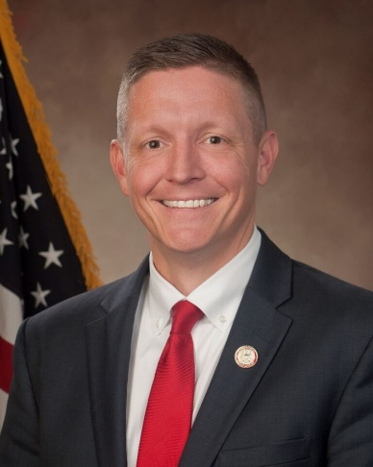
Paul Holley serves as the Director of Strategic Law Enforcement Partnerships for the Mississippi Attorney General’s Office under the leadership of Attorney General Lynn Fitch. In this vital role, he is responsible for cultivating and maintaining critical partnerships between local, state, and federal law enforcement agencies throughout Mississippi.
Mr. Holley brings a unique perspective to public safety, having served as both a prosecutor and a full-time law enforcement officer. A graduate of the 285th session of the FBI National Academy, Mr. Holley continues to demonstrate his commitment to professional excellence and leadership within the law enforcement community. He currently serves as the 2nd Vice President of the Mississippi Chapter of the FBI National Academy Associates (FBINA).
Mr. Holley earned his undergraduate degree from Mississippi State University and his Juris Doctorate from the Mississippi College School of Law. He resides in Rankin County, Mississippi, with his wife, Leslie, and their two children, Maddy and Max.

Barb Bergin

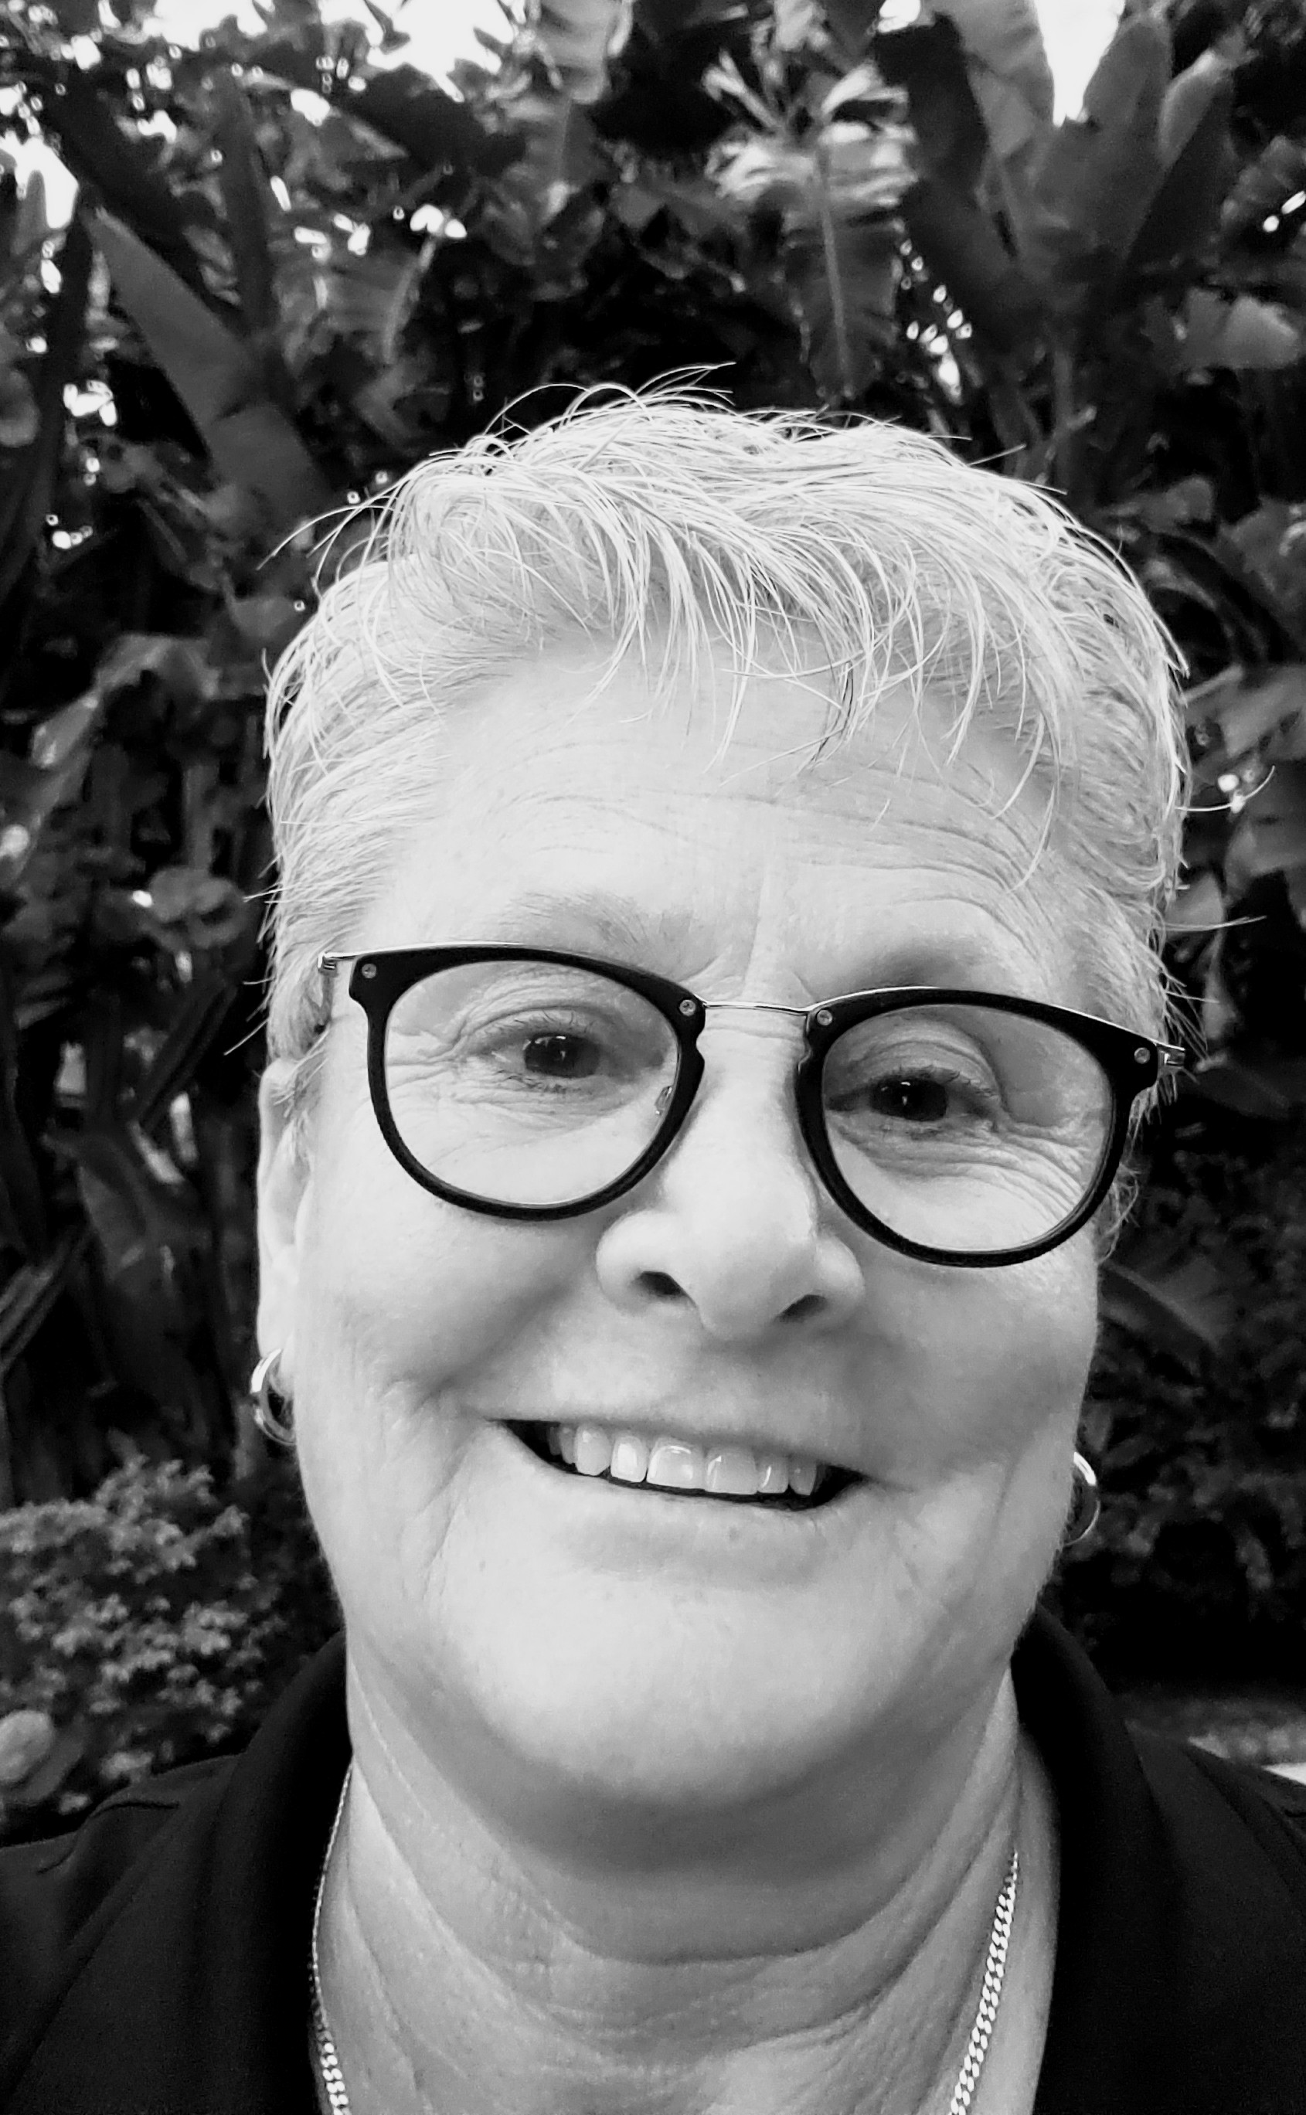
She attended JC Stone Law Enforcement Academy in Orlando during 1983 and was sworn in as a police officer September 3, 1983. Her career included 8 ½ years in uniformed patrol primarily working the west side of Orlando. The patrol assignment was followed by 12 years as a detective, including 1 ½ years in the Sex Crimes unit and 10 ½ years in the Homicide unit. While in the Homicide unit she utilized Crime Stopper tips to solve many cases.
Barb received Officer of the Year awards from the Orange County Bar Association as well as the Orlando Police Department. She has studied at Valencia Community College and Rollins Hamilton Holt College.
Prior to retiring in February of 2009 Barb Bergin was assigned to Central Florida Crimeline as the Law Enforcement Coordinator. While assigned to the program Barb recognized the need to educate the “tip rich” communities on Crimeline. The number of tips annually began increasing and has now reached an average of 8,000 tips a year. Crimeline covers six counties with a population of 4 million people. Barb has been the Executive Director of Central Florida Crimeline for the past 15 years.
Barb has served at President of the Florida Association of Crime Stoppers and the Chair of Crime Stoppers USA. Currently she is the CEO for CSUSA.

Felicia McIntire
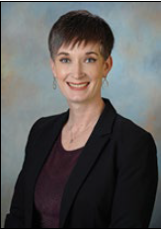
Felicia McIntire holds a Bachelor of Science degree in Forensic Chemistry from Eastern Kentucky University. She received her Forensic Firearms Identification and Controlled Substance Identification training at the Indiana State Police Laboratory from 2005 to 2007. In 2008 she began her career with the Mississippi Forensics Laboratory, assuming the Firearms Section Chief position in 2017 and Assistant Director in 2025. Her duties include overseeing the administrative and technical aspects of the Impression Divisions of the Forensics Lab, performing casework pertaining to firearm and ammunition component comparisons, serial number restorations, muzzle to garment range proximity, toolmark comparisons and NIBIN database entries. Mrs. McIntire is a diligent professional who has been praised as an Outstanding State Law Enforcement Officer by the United States Attorney for the Southern District of Mississippi. She is active in evaluating research in her perspective field as a member of the Steve Molnar Key Person of the Year Committee of the Association of Firearm and Toolmark Examiners (AFTE). She is also a member of the Midwesten Association of Forensic Scientists (MAFS) and the Mississippi Division of the International Association for Identification (MDIAI). She has earned the diplomate certification in Comprehensive Criminalistics from the American Board of Criminalistics (2011 to present).”

Laura McElroy
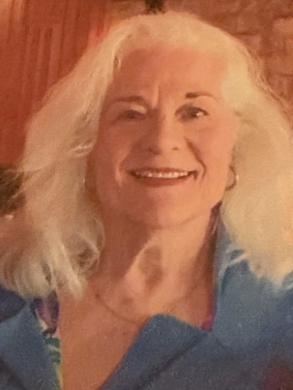
Work Experience includes stint 1972-75 in Washington D.C. as staff for Chairman George H. Mahon (House Appropriations Committee); Staff Counsel, Economic Analysis Center, Texas Comptroller of Public Accounts Bob Bullock (1988-89); General Counsel, Texas Senate Committee on Redistricting (1990); Director of Redistricting, Texas Comptroller of Public Accounts John Sharp (1991-1993); Director of Controlled Substances Tax Collections, Texas Comptroller of Public Accounts John Sharp (1993-1996 General Counsel, Texas Board of Pardons and Paroles, 1996-2007; Prosecutor in Lubbock County (1982-1984), and Travis County (2007-2012) — Handled criminal trials in state court, as well as appellate work and grand jury work; Board Member and Officer, Taos County (NM) Crime Stoppers, 2015-present; Board Member, Crime Stoppers USA, 2025-present; Member, CSUSA Legal Advisory Committee (assisting Judge Richard W. Carter (Ret.), Director of Legal Services, Crime Stoppers of the United States of America, Inc.).

Keynote Speaker
Geoffrey Kelly
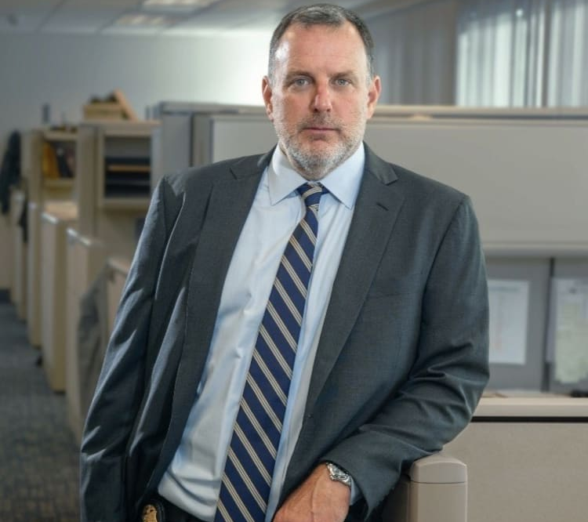
In April 2024, Geoffrey Kelly retired from the FBI with more than thirty years of federal and state law enforcement experience. As one of the original members of the FBI’s elite Art Crime Team, founded in 2004, Geoff managed numerous high-profile cases throughout his career, and recovered more than $100 million in stolen artwork and cultural property; items as diverse as rare books, fine art, Native American artifacts, looted Okinawan treasures – even Tom Brady’s stolen Super Bowl jerseys.
An internationally recognized expert in the field of fine art and antiquities theft, Geoff has traveled the world, training domestic and international agencies and institutions on proven methods and best practices to deter art and cultural property theft.
For more than two decades, Geoff was the FBI’s lead investigator into the March 1990 robbery of the Isabella Stewart Gardner Museum in Boston. This past March, Geoff released “Thirteen Perfect Fugitives: The True Story of the Mob, Murder, and the World’s Largest Art Heist”. The book, published by Post Hill Press and distributed through Simon & Schuster, details the more than two decades he spent as the case agent on this infamous crime.
After retiring from the FBI, Geoff and his colleagues formed Argus Cultural Property Consultants, a consulting firm dedicated to the preservation and protection of art & cultural property worldwide.
Geoff is a graduate of Boston University and earned his master's degree in Criminal Justice, also from Boston University. He serves as an instructor at Harvard University’s Extension School, teaching a graduate-level course on art crime and investigations.

Rebecca Chaney
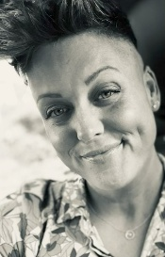
Rebecca Chaney serves as the Targeted Violence and Threat Prevention (TVTP) Statewide Trainer and Community Liaison for the Mississippi Office of Homeland Security. She brings a diverse background in education, behavioral therapy, public service, and community engagement to Mississippi’s violence-prevention efforts.
Rebecca holds a Bachelor of Science in Education from Mississippi College with additional certification in Special Education. Her professional experience includes teaching in Mississippi public schools and working in Applied Behavior Analysis with individuals across a variety of ages and settings, including clinical, hospital, and private-home environments.
For several years, Rebecca also served as Director of Restore Liberty Mississippi, a veteran-founded nonprofit organization, where her work focused on research, community education, and teaching United States constitutional literacy. Her research and writing were published through a variety of outlets, and she appeared on multiple national podcasts discussing constitutional, civic, and public-policy issues.
In her current role, Rebecca works to strengthen Mississippi’s capacity to prevent targeted violence through training, education, Behavioral Threat Assessment and Management (BTAM), and multidisciplinary community partnerships. She is a Master Behavioral Threat Assessment and Management Trainer and holds multiple certifications related to targeted violence and threat prevention.
Rebecca believes that what we value drives our behavior and that lasting violence prevention begins with the individual. Healthy, healed individuals are the foundation of healthy families and thriving communities. Her work is grounded in shifting from a culture of violence toward a culture of thriving through personal responsibility, prevention, and whole-of-community collaboration.

Jim Brinson
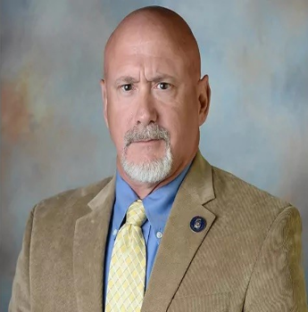
As Executive Director of the Mississippi Office of Homeland Security, Jim Brinson leads the critical mission of protecting Mississippi's citizens, critical infrastructure, and governmental institutions. A distinguished instructor and security expert, he has shaped the state's comprehensive security strategy since 2004, bringing his expertise as a Certified Counter-Terrorism Operations Specialist with advanced training in Weapons of Mass Destruction (WMD) Terrorism Tactics and Targeted Violence.
Working closely with the FBI Joint Terrorism Task Force, Brinson oversees a complex network of security operations designed to safeguard Mississippi's vital assets and communities. His responsibilities include managing terrorism response assets, directing the state's active shooter preparedness and training programs, and coordinating State Search and Rescue (SAR) operations. As a sworn law enforcement officer, he actively investigates and responds to potential and confirmed cases of terrorism and violent threats that could impact state security.
Drawing from his distinguished career with the U.S. Air Force, where he responded to terrorist incidents and led counterterrorism operations worldwide, Brinson has developed and implemented robust protection protocols for Mississippi's essential infrastructure, government facilities, and public spaces. His comprehensive approach to security ensures continuous monitoring and protection of the state's most valuable assets and citizens.
Brinson develops and delivers critical training programs to military personnel, law enforcement agencies, and civilian groups nationwide as a lead instructor in active shooter preparedness and response. He specializes in teaching survival tactics and response strategies for active attack scenarios, ensuring participants are well-prepared for potential threats. His expertise extends to security measures for major sporting events, where he trains law enforcement agencies in various counterterrorism areas. A sought-after speaker and educator, Brinson regularly presents to local, state, national, and international audiences on terrorism and targeted violence prevention.
Throughout his career with the Mississippi Office of Homeland Security, Brinson has established himself as a leading expert and instructor in counterterrorism operations, combining practical field experience with advanced tactical knowledge to enhance the state's security infrastructure and emergency response capabilities. His unwavering commitment to public safety and excellence in training continues to strengthen Mississippi's resilience against evolving security threats.
Kristi Johnson
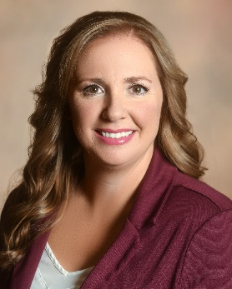
As an Instructor of Forensic Science at The University of Southern Mississippi’s School of Criminal Justice, Forensic Science and Security, Ms. Kristi Johnson utilizes her education and practical experience to instruct students in introductory and advanced forensic topics. Ms. Johnson’s practical experience stems from 12 years as a Crime Scene Investigator and Evidence Custodian on the MS Gulf Coast. As a CSI, Ms. Johnson spearheaded efforts to advance investigative techniques for cold cases, especially missing and unidentified persons, across the coast and beyond and continues these efforts at USM. She is a board member for the Mississippi Division of the International Association for Identification, a professional organization for law enforcement and forensic scientists. She holds a Bachelor of Science in Forensic Science and a Master of Science in Criminal Justice. Ms. Johnson is also a founder and the current President of Reunite Mississippi, a 501 c 3 nonprofit supporting families of the missing and law enforcement.

Johnny Poulos
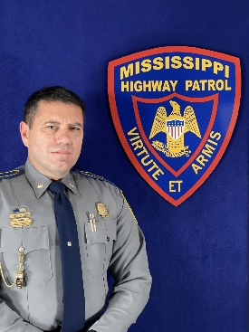
Major Johnny Poulos, a 27-year veteran of the Mississippi Highway Patrol, currently serves as the Director of the 10-34 Project, a statewide initiative dedicated to promoting officer wellness and resiliency. In addition, he also leads the implementation of the Law Enforcement Interaction Course, which will be integrated into all Driver Education programs across Mississippi.
From 2011 to 2021, Major Poulos served as Director of the Public Affairs Division, during which time the division earned eight national awards for excellence. He is a certified defensive driving instructor through the National Traffic Safety Institute, a critical incident debriefer, and a field training officer with the Mississippi Department of Public Safety. In 2025, Major Poulos was selected as Chairman of the Mississippi First Responder PTSD & Suicide Prevention Task Force.

Lori Massey
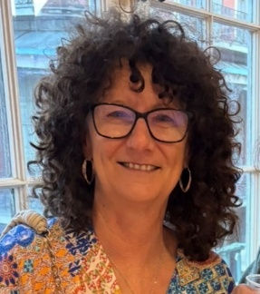
Lori Massey is the CEO of Mississippi Coast Crime Stoppers and a member of the Mississippi Crime Stoppers Advisory Board. On the national level, Lori serves as Secretary of Crime Stoppers USA (CSUSA) and has previously served as Regional Director for two different regions. In 2020, she was honored with the Crime Stoppers USA Chairman’s Award.
A frequent speaker at community events and conferences, Lori is dedicated to educating the public and law enforcement about the mission and operations of Crime Stoppers. Under her leadership, Mississippi Coast Crime Stoppers has built one of the strongest Crime Stoppers social media presences in the country. Its extensive reach and community engagement have become powerful tools for generating tips, assisting law enforcement, and contributing to numerous arrests.
Lori played a crucial role in initiating the University Cold Case Project on the Mississippi Gulf Coast. She considers the creation and printing of Mississippi’s first unsolved homicide and missing persons cold case playing cards, distributed to inmates to generate new leads in unsolved cases, to be her most significant accomplishment to date.
As a trainer at the Harrison County Law Enforcement Training Academy, Lori teaches cadets about the mission of Crime Stoppers, the importance of anonymous tip programs, and how law enforcement can effectively utilize Crime Stoppers as an investigative resource.
In addition to her work with Crime Stoppers, Lori serves on the boards of the Gulf Coast Center for Nonviolence, Tunnel to Towers Biloxi, and Reunite Mississippi.

Sean Tindell
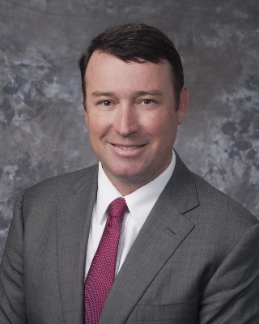
As the Commissioner of the Mississippi Department of Public Safety, Commissioner Tindell oversees the Mississippi Highway Safety Patrol, the Mississippi Bureau of Investigation, the Mississippi Bureau of Narcotics, the Mississippi Law Enforcement Officers’ Training Academy, the Driver Service Bureau, the Mississippi Office of Homeland Security, the Mississippi Forensics Laboratory, the State Medical Examiner’s Office, Crime Stoppers, and Public Safety Planning. Commissioner Tindell currently manages over 1,100 employees throughout the state.
Commissioner Tindell was appointed by Governor Tate Reeves to lead the Mississippi Department of Public Safety in May 2020. Prior to joining the Mississippi Department of Public Safety, he served as a Judge for the Mississippi Court of Appeals, representing District 5, Position 2. Commissioner Tindell was appointed by Governor Phil Bryant to fill the vacancy created by Judge David Ishee’s appointment to the Mississippi Supreme Court. Commissioner Tindell also served in the Mississippi Senate, representing District 49, from 2012 until his appointment to the bench. He was chairman of the Senate Judiciary A Committee and vice chairman of the Senate Tourism Committee. He also previously served as Assistant District Attorney for the Second Circuit District of Harrison, Hancock, and Stone counties from 2002 to 2007 and City Prosecutor for the City of Biloxi from 2008 to 2011. In his private law practice, Commissioner Tindell represented a number of business clients and governmental bodies, including the City of Diamondhead, the Stone County Utility Authority, Harrison County, and the Orleans Parish District Attorney. In addition to practicing law, Commissioner Tindell held a real estate broker’s license and actively managed his own commercial and residential rental properties.
Commissioner Tindell holds a Juris Doctorate degree from the Mississippi College School of Law, where he served as student body president and earned honors of American Jurisprudence in counseling, negotiations, and domestic relations. He also holds a Master of Business Administration degree and a Bachelor of Science in Business Administration degree from the University of Southern Mississippi. He also participated in a study abroad program with an emphasis in finance at the London School of Economics.
Commissioner Tindell grew up on the Mississippi Gulf Coast. He and his wife, Claire, reside in Gulfport with their four children, Sam, John Thomas, Meredith, and Henry. In his spare time, Commissioner Tindell enjoys tending to his farm in Stone County and coaching youth sports.

